26.6: a)
b) The current in each resistor is the same and is 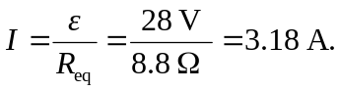
c) The current through the battery equals the current of (b), 3.18 A.
d)
e)
f) For resistors in series, the most power is dissipated by the resistor with the greatest resistance since 